Launch Editor Component for Anusaaraka’ Rules
Table of Contents
1 Introduction 2
1.1 Launch the Rule with associated Editor 2
1.2 Document Purpose 3
1.3 Development Approach 3
2 Functional Description 4
2.1 Command Line Utility (Shell Script) 4
2.1.1 Development components 5
2.1.2 Feasibility Analysis 5
2.2 Utility Plug-in 6
2.2.1 Sample Plug-in #1 8
2.2.2 Sample Plug-in #2 8
2.3 Cross Platform Component 9
2.3.1 Browser UI framework 9
2.3.2 Launch Editor 9
3 Assumptions 11
3.1 Feasibility Status 12
3.2 References 12
Figure 1 Anusaaraka Translation output window 3
Figure 2 Shell script functional blocks 6
Figure 3 Utility plug-in Class. 8
Figure 4 Mozilla UI toolkit architecture 10
Figure 5 Openwith Windows Dialog for Unknown extensions 11
Figure 6 Openwith linux dialog for unknown file extensions 11
Figure 7 Launch Editor Component blocks 12

Anusaaraka Word Translation: Approach to Launch Editor(s) for Rule files

Introduction
Anusaaraka’s translation output is a tabular display embedded in a web page. The translation of a given English word depends on the rule that is provided to the Anusaaraka’s interface for translation.

Figure 1 Anusaaraka Translation output window
A sample output of Anusaaraka’s word aligned translation is displayed as shown in the figure below:
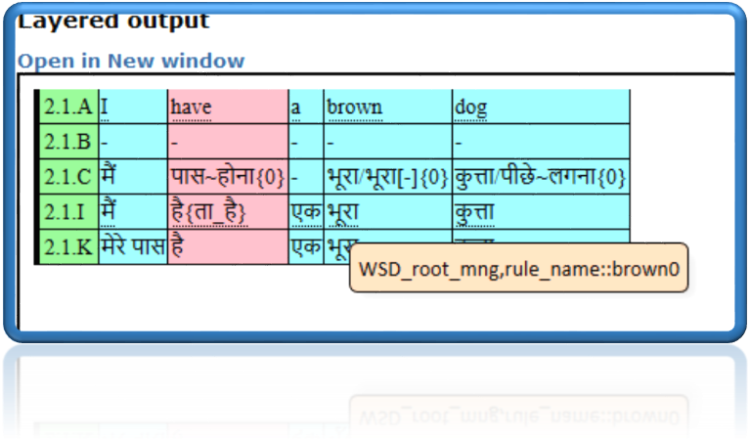

T
he rectangular pop-up on the output table is referred to as ‘tooltip’. The tooltip content is a string that has an associated rule file employed for this sample translation. In the sample the rule name is brown0 which is deployed to translate the word ‘brown’ in the sample. The rule is a part of a CLIPS format rule file.

Launch the Rule with associated Editor
The rule that is shown in the tool tip is shown as a reference to the user/developer of the Anusaaraka project. The user interface requirement in this context is for the development of a software utility that can:
- Launch the CLIPS script file in an appropriate editor that will help the developer identify the problem within the translation while reviewing the output.
- The utility sw should be able to list the available editors in the user’s (developer’s) login profile (user’s desktop/user’s login) and the developer should be able to “select” the editor with which the CLIPS script can be modified.
- The selected editor should be launched on the developer’s desktop with the contents of the rule file, while the Anusaaraka’s output window is active within the browser application.
- The developer should be able to “edit” the script, make modifications and save the modified file with the help of editor commands and return to the Anusaaraka output window within the browser.

Document Purpose
This document is intended to provide an approach to the sw utility requirement mentioned in section 1.1. The requirement can be designed to a utility with several developer perspectives. The document presents 2 of them with a confidence in feasibility.

Development Approach
The following table lists possible solutions to is requirement. In the below mentioned solutions, Mozilla’’s Firefox browser has been assumed to be a preferred browser by the Anusaaraka project team

S.No | Approach | Description | Insights | Comments
 | To develop a shell script that takes the file url as an argument and invokes the native editors of the Operating System. | The script can be executed as a command line utility or embedded mode from a rudimentary script launched from a web page interaction  The rule file name attached with the translated word is passed to a profile based shell script that executes a shell command to launch an editor | Shell script is closely coupled with the user’s profile, hence requires to be copied into each of the developer’s profile. | The shell script will need to be modified to be executed on both Windows based and Linux based desktops., or there is a need to develop a utility that runs on Windows based desktops
 | To develop a Java program that executes the command to launch the editor. | The rule file name is passed to the Java program and program has the ability to pop up the list of installed editors , the user is provided with a choice to select one among them and the file is opened in the selected editor | The program becomes cross platform, however will still need to have a profile kind of input to get the list of installed editors | A mock program which is functional on Windows platform is available from popular web resources
 | A Javascript Component plugin that ‘captures’ the mouse clicks on the Anusaaraka’s output window and invokes browser’s utility that has the same features as the standard browser’s way to list the user’s preferences for editing the file | This development is based on the assumption that the Anusaaraka’s output window is based on Javascript/HTML. A mouse click on the word column will only be used to pop up the ópenwith’ dialog of the native browser.  The native browser dialog shows the installed editors/applications to the user and user is able to select one of them | This solution is completely platform agnostic and based on the Browser’s component Object model. This approach is assumed to be functional on both Windows and Unix based desktops for Firefox browser. A component object framework is available for both IE and Firefox web application developers. | - The development effort is longer.  - Feasibility has not been established with Unix based desktops  - Feasibility for Windows desktops is discussed within a web forum

Functional Description
The purpose of this section is describe the functional blocks of each of the solutions described in section 1.3.

Launch Editor as Command Line Utility (Shell Script)
The figure below represents an approximate functional block diagram of a shell script utility for the requirement.
Anusaaraka User Interface (output window/web page)
Javascript code to capture the rule file name
Javascript Interpreter (native to OS)
0)
Shell command to invoke editor
Vi/notepad (brown CLIPS file)

Capture the mouse click at the specific location to get the rule file name and send to the Javascript below as an input

Send the file name as an argument to the shell script, launch the editor as in user’s profile and wait for the editor to close , return to the javascript

Figure 2 Shell script functional blocks

Development components
The approach described in this section is a developer profile and OS dependent solution with the development components being very thin and profile dependent. By profile dependent, it is assumed that shell and editor are user profile specific preferences. This solution does not provide an option to dynamically select an editor of user’s choice. The solution should also be able to capture the filename depending on the (x,y) coordinates of the mouse click on HTML element of the Anusaaraka’s output web page

Sample Scripts
The approach described in section 2.1 is checked for feasibility as described below. A sample text file is passed as an argument to:
- A bash shell script
- A Javascript interpreter such as Rhino shell.
The shell script includes the command line to launch the editor.
#!/bin/bash
# My first script
vi myfile.txt < `tty` > `tty`
#echo "Hello World!
A sample bash shell script with the following content may be executed at a shell prompt. In the sample script above, “myfile.txt”” should be command line argument which is none other than the rule file to be passed to the script. In a similar way, with a native Javascript interpreter plugged into user’s profile, command to execute the editor with the rule file name as argument to the command can be checked. For e.g. at a Rhino Javascript Command Shell the following can be executed:
Rhino_js>
Rhino_js>runCommand(“xterm”, “-e”, “vi”, “myfile”)
0
Rhino_js>

Launch Editor as Utility Class plug-in
The application plug-in solution assumes that a Java class utility can be plugged into Anusaaraka’s output window web page. The utility class will have desired functionality as follows:
- Capture the file name and launch a command shell along with the ‘specified’ editor or
- Invoke run time environment of the OS , launch the native “openwith” dialog for the browser(IE/FireFox) and pass the command to the run time environment to launch the selected editor with the rule file. A representative block diagram is as follows: (image courtesy: Microsoft, Mozilla Firefox)
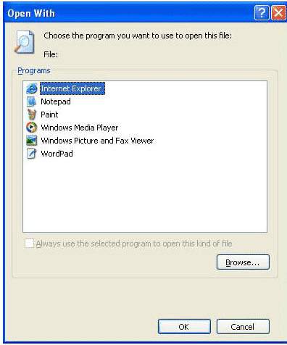
Java class utility to get the native run time environment
Vi/notepad (brown CLIPS file)
Anusaaraka’s output window web page
Command shell of the native OS

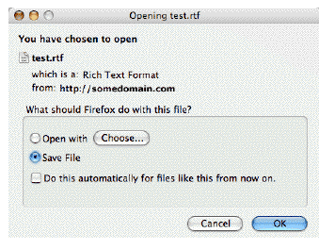

Figure 3 Utility plug-in Class.

Sample Plug-in #1
A proof of concept class was sample tested for the Utility plug-in, as mentioned in the code block below. The sample class accepts a file name argument, which in this case is the Rule file for ‘brown’ and executes the command to ‘”notepad””. This sample does not pop up an ópenwith’ dialog to the developer
import java.util.*;
public class notepad
{
public static void main(String[] args) {
try{

String fileName =args[0] ;
String[] commands = {"cmd", "/c", fileName};
Runtime.getRuntime().exec(commands);
}catch(Exception e){
System.out.println("Exception"+e);
}
}
}

Sample Plug-in #2
Popular forums online, recommend a solution to programmatically launch an editor as seen in the code sample below. This solution seems to invoke th runtime environment on Windows based desktops with the help of native framework support. The native framework for browser UI seem to provide ‘named access’ to invoke the pop up dialog that contains a list of editor executables to the user. The sample is not test executed to confirm the functionality, since the recommendation is from an authentic source. A similar sample needs to be developed for linux based systems.
using System;
using System.Diagnostics;
using System.IO;

class Program {
static void Main(string[] args) {
ShowOpenWithDialog(@"myfile8i");
}
public static void ShowOpenWithDialog(string path) {
var args = Path.Combine(Environment.GetFolderPath(Environment.SpecialFolder.System), "shell32.dll");
args += ",OpenAs_RunDLL " + path;
Process.Start("rundll32.exe", args);
}
}

Cross Platform Component
A cross platform component development approach can be thought of as concrete solution to the requirement of launching an editor for the CLIPS rule. The advantage of designing a cross platform component is that the solution becomes OS independent, but specific to browser UI framework. The approach discussed in this section is drafted with Mozilla’s XUL/XPCOM browser developer framework. Similar browser developer frameworks exists for Internet Explorer
Component Object have well defined interfaces to help processes interact with each other without violation of security privileges. The ‘’launch an editor’’ utility needs to request an access to editor that is native to the OS via a connection object to the runtime environment process. Once the access is granted, the utility can launch the editor application.
A typical user interface model for Firefox web application is as below:
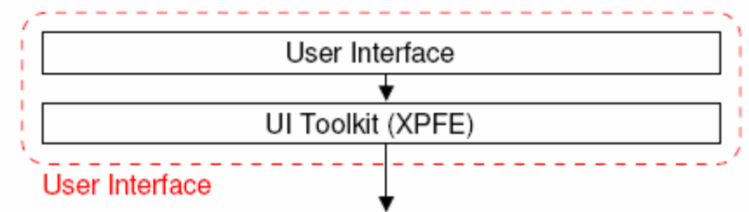
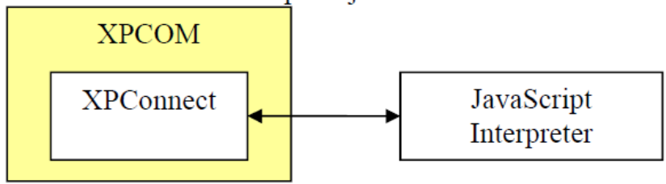
Figure 4 Mozilla UI toolkit architecture

‘Launch Editor’ as Cross Platform Component
Launch Editor Component can be developed using XPFE/XPCOM object interfaces within a Javascript. The idea is to leverage on XPCOM architecture to access the runtime command execution environment on any OS. The justification is that Anusaaraka’s output window is web-enabled application and any utility that is add-on to Anusaaraka should be a web enabled component. XPCOM is a Mozilla web development framework object with defined interfaces to connect to runtime environment process on the native OS.

Component Elements
Launch Editor component is a javascript component that will embed XUL(UItool kit) and XPCOM framework objects., The XUL framework has UI components that can read user preferences for Firefox UI functionality. User preferences are stored as javascripts in a pre-defined location for Firefox to apply in each session. The XUL component within the Launch Editor utility should be able to read these preferences via object query interfaces.
The preferences will have an action defined when a file type does not find an associated editor. The action defined will be to launch a dialog window as below for windows based editors such as ”Notepad” or “Wordpad”, or the common linux openwith dialog as in figure 6
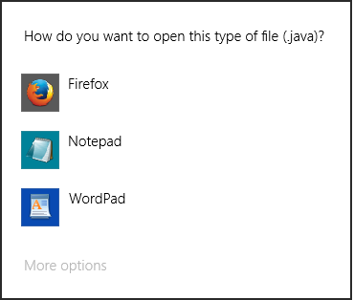
Figure 5 Openwith Windows Dialog for Unknown extensions
Figure 6 Openwith linux dialog for unknown file extensions
The user can choose an available editor from the list displayed in the dialog and the javascript will launch the editor via XPCOM interface that runs the command to launch the editor. A functional block diagram of this approach is as follows:

Execute runcommand interface with the chosen editor
Invoke openwith dialog
Anusaaraka’s user interface output window webpage
Javascript component utility
Javascript interpreter
XPCOM Interface
XPCOM Object for editor preferences
XPCOM object for runtime environment
Browser preferences read it from user’s profile
Native editor launched with brown’s rule
Execute run command
Read user preferences
XUL interface for browser preferences

Figure 7 Launch Editor Component blocks

Assumptions
All the models discussed in the above sections are based on the following assumptions:
- Anusaaraka’s output window is based on Javascript enabled web page
- Anusaaraka’s users or developers use both Internet Explorer on Windows and Firefox browser on Windows and Linux/Unix based desktops
- The CLIPS rule file location is a profile variable modified during installation of Anusaaraka engine repository
- CLIPS file can be edited both on Windows and Linux/Unix based desktops
- It is possible to capture the rule file name from the output window via HTML interfaces
- For approach discussed in section 2.3 Firefox browser’s editor preferences are accessible via XPCOM interface
- Editor preferences for linux/Unix based desktops can be read via Javascript.+ cross platform component object interfaces
- Browser UI toolkit provides a method to invoke Ópenwith’ dialog via the component object model.

Feasibility Status
The following table presents the feasibility analysis status of the models
Model | Runtime Environment | OS | Browser | Functional status
Launch editor as Command Line utility | Cygwin/bash shell | Windows | NA | Sample execution
 | Rhino/Javascript Command line shell | Window | NA | Sample execution
Launch editor as Utility class | JRE 1.7 | Windows | NA | Sample execution
 | JRE## | Windows | InternetExplorer | Web resource confirmation
Launch Editor Cross Platform Component | Mozilla developer network UI framework | Windows | Firefox | Web resource confirmation
 | Same as above | Unix | Firefox | To be analysed for feasibility

References
The document is made with the analysis of existing browser architectures and available web resources. Some useful references are as below:
- MOM Anusaraka 17 Jan 2015—Word document shared by Aagama Technologies with IIIT team
- http://web.uvic.ca/~hitchner/assign1.pdf
- https://developer.mozilla.org/en-US/docs/Mozilla/Preferences/A_brief_guide_to_Mozilla_preferences
- http://forums.pentaho.com/archive/index.php/t-51525.html
- http://stackoverflow.com/questions/5742128/javascript-standalone-compiler-or-interpreter-for-windows
- http://stackoverflow.com/questions/2035678/how-to-open-files-in-web-browsers-e-g-firefox-within-editors-like-vim-or-emacs
- http://www.codeproject.com/Articles/13103/Calling-the-Open-With-dialog-box-from-your-applica
- http://tiku.io/questions/269524/how-can-i-display-the-open-with-dialog-for-an-unregistered-file-extension
- http://tiku.io/questions/4604823/how-can-i-open-a-local-file-with-a-local-program-through-my-browser
- https://github.com/aabeling/commandrun
- https://developer.mozilla.org/en-US/docs/Mozilla/Tech/XPCOM/Reference/Interface/nsIProcess
- http://stackoverflow.com/questions/2035678/how-to-open-files-in-web-browsers-e-g-firefox-within-editors-like-vim-or-emacs
- https://github.com/aabeling/commandrun
- http://kb.mozillazine.org/Profile_folder_-_Firefox#Linux
- http://www-archive.mozilla.org/docs/end-user/helper-applications.html

http://anusaaraka.iiit.ac.in/node/1018

